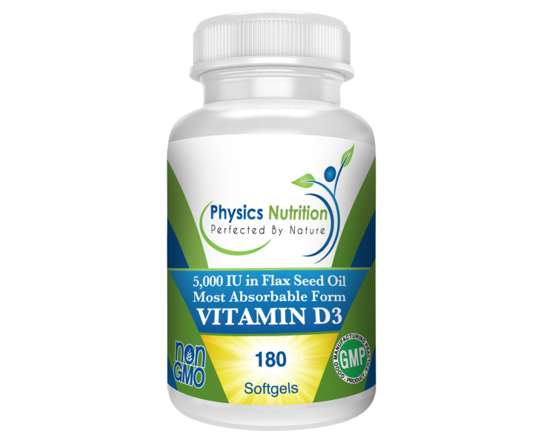
What if there was a supplement that was only $3 per month and has been shown to:

- Improve Immune System Function (you get sick less)
- Improve Muscle Function
- Improve Cardiovascular Function (for a healthy heart and circulation)
- Improve Respiratory System Function (for healthy lungs and airways)
- Improve Brain Development
- Have Anti-Cancer Effects

Would you take it? Of course! Let me explain why, how much, and what kind is the best.

Vitamin D is an “essential nutrient.” What “essential” means is that you need it to survive and your body cannot produce it; therefore, you have to get it from an outside source.

An easy analogy to understand is sunlight for plants. A plant will die if it doesn’t get any sunlight. If the plant gets some sunlight it will survive, but it won’t thrive like it would if it was getting all of the sunlight it needed. The ways sunlight benefits the plant are countless. The fact is, if a plant gets all of the sunlight it needs it will thrive. If it gets some sunlight but not optimal amounts it will live but not be very healthy. If it gets no sunlight it will die.

This is exactly how Vitamin D works for you. If you are getting the required amounts of Vitamin D, all of the countless systems in your body that are affected by Vitamin D will work properly. If you are getting some vitamin D, but not enough, you can survive; but you won’t be healthy. If you get zero Vitamin D you will die. If you don’t have optimal levels of an essential vitamin you cannot be at optimal health. It really is that simple.

So where does Vitamin D come from? Just like a plant needs the sunlight to survive, your body gets Vitamin D from sunlight. When sunlight hits your skin your body produces the “hormone” Vitamin D. Yes, it is actually considered more of a hormone than a vitamin. A hormone that you need to survive!

Now here is the problem. People rarely get enough sunlight on their skin, which causes us to be deficient in Vitamin D. Think about winter. You wake up when it’s dark. You sit under artificial lights all day at work. You then leave work in the dark. There is so little sun exposure that it’s not possible to get adequate amounts of Vitamin D production.

Now think about this. Winter is cold/flu “season.” It is absurd to think that there are more bacteria or viruses floating around in the winter months. Viruses and bacteria, good and bad, are around us constantly. What happens is days are shorter, days are colder, and we cover up our skin and get little to no sunlight. Our Vitamin D production goes down and our immunity goes down. Vitamin D is essential for an optimally functioning immune system.

Lowered Vitamin D levels = lowered immune function = increased sick days.

Another problem is this recent fear mongering that sun will cause skin cancer and you need to live in a cave or lather yourself in toxic sun screens 24/7. Here’s the thing. Sun is very healthy…until you burn yourself! Marketing has us believing all sun is bad. It’s not. It is only bad in excess! This fear of the sun is also a contributing factor in our Vitamin D deficiency epidemic.

I have read that a person needs to get 15 minutes of direct sunlight per day on fully exposed arms and legs. This is just a vague average. People with darker skin need more time in the sun than fair skinned folks, and how close you are to the equator makes a difference; there are so many factors that it’s hard to tell exactly how much sunlight you need.

Think about skin color and human evolution. Our ancestors that lived closer to the equator had darker skin. People living in northern climates or areas of less sun exposure had lighter skin. Over time people evolved to be able to absorb sunlight and produce vitamin D more efficiently. People with darker skin need longer time in the sun to produce adequate vitamin D levels. Dark skinned people living in northern, less sunny climates rarely have sufficient Vitamin D levels. What is known for sure is that the vast majority of people does not get enough sunlight and are deficient in this essential nutrient.

Now for the great news…..Vitamin D supplementation is a very effective and a very inexpensive way to boost your vitamin D levels to optimum. There are two kinds of Vitamin D available; Vitamin D2 (ergocalciferol) and Vitamin D3 (cholcalciferol). Only buy Vitamin D3! It is the naturally occurring form, the most absorbable and most beneficial. Notice the CHOL in Cholcalciferol…CHOLesterol is also a hormone. Sunlight basically turns cholesterol into cholcalciferol (Vitamin D). Your body is so amazing. It works perfectly if we just give it the right pieces…and don’t poison it with junk!

I recommend about 5,000 IU’s of Vitamin D per day for adults and 35 IU’s per pound per day for kids. So a 50 pound child should get about 1750 IU’s of vitamin D per day. When it comes to Vitamin D, it is next to impossible to take so much that it causes harm. I don’t ever worry about that. An analogy I once heard is “living in America today while worrying about vitamin D toxicity is like dying of thirst in the desert while worrying about drowning.”

You can go to the hospital and get your vitamin D levels checked. When you do the hospital will write you a Vitamin D prescription (often D2, the bad form) at 50,000 IU’s once per week. I have no idea why that is. Taking some every day makes a lot more sense than taking one massive amount once a week. Maybe that dose is needed for a prescription to be required.

Whenever you take any vitamin, it is very important that the vitamin is actually absorbed into your body. A vitamin is absolutely useless if it just ends up in the toilet. Vitamin D is fat soluble and thus best absorbed when taken with a fat.

Each perle contains 5,000 IU’s of Vitamin D3 in Flax Seed Oil. You are getting the best form of Vitamin D in a healthy Omega 3 fat to ensure maximal absorption. The only better option would be to get adequate amounts of sunlight on a regular basis.

180 perles (or a 6 month supply) is only 11 cents per day. This is why I think supplementing Vitamin D is such a no-brainer. For only $3 per month you can drastically improve your health.

For kids not old enough to swallow pills, we have Vitamin D in certified organic olive oil, in a little glass bottle with an eye dropper. You can just put a couple drops in their food, bottle, or directly in their mouth.

“But I feel fine….” I always have two answers for this.

One – fine is not good enough! I want you to feel awesome.

Two – Waiting until you feel bad or get sick before taking action is foolish. Keep adequate amounts of Vitamin D in your system and avoid getting sick all together!

